DOMAIN MODEL(CONCEPTUAL CLASS,domain object model and analysis object models)
- IT illustrates noteworthy concepts in a domain.
- IT helps to design software objects.
- It is a visual representation of conceptual classes or real situation objects in a domain.
- It is not of software objects.

APPLYING UML : DM is explained with Class diagram with no operations are defined.
It may show
Domain objects or conceptual classes
Associations between conceptual classes
Attributes of conceptual classes

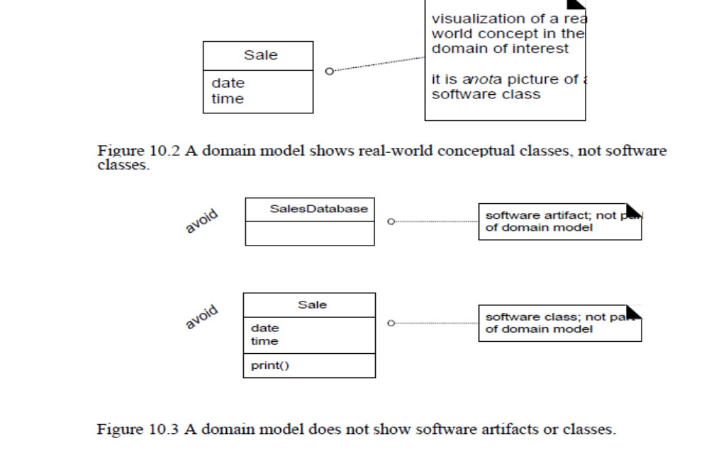

Domain Model illustrates conceptual classes or vocabulary in the domain.
Informally, a conceptual class is an idea, thing, or object.
More formally, a conceptual class may be considered in terms of its symbol, intension, and extension
Symbol—words or images representing a conceptual class.
Intension—the definition of a conceptual class.
Extension—the set of examples to which the conceptual class applies.
For example, consider the conceptual class for the event of a purchase transaction.We may choose to name it by the symbol Sale. The intension of a Sale maystate that it "represents the event of a purchase transaction, and has a date and time." The extension of Sale is all the examples of sales; in other words, the setof all sales.
The three strategies to find conceptual classes
Reuse or modify existing models(First,Best,and easiest approach). There are published ,well crafted domain models and data models for many common domains ,such as inventory,finance,health,banking,and so forth.
Use a Category List

Business transactions | Sale,Payment
Transaction line items | SalesLineItem
Product or service related to a transaction | Item
Where is the transaction recorded | Register,Ledger
Actors in the use case.roles of people to the related transaction | Cashier,Customer ,Stire
Place of transaction | Store
Noteworthy events (time and place to remembet) | Sale,Payment
Phsyical objects | Item,Register
Description of things | ProuctDescription
Catalogs | Product Catalog
Container of things | Store,bin
Things in a container | Item
Other collobrating system | CreditCard Authorization system
Records of finance,work,contracts,legal matters | Receipt
Financial Instruments | Cash,Check,LineofCredit
Schedules,manuals | DailyPrice Change List

Identify noun phrases.

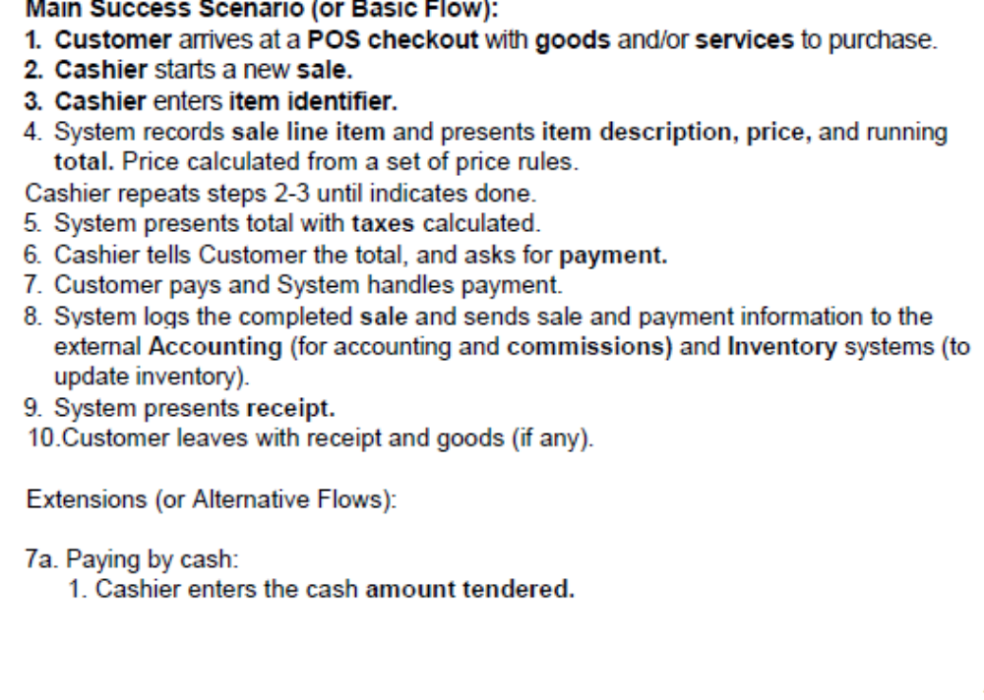

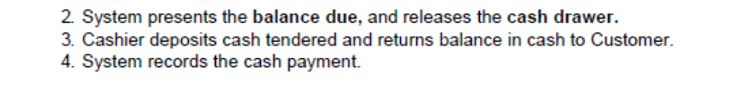

How to create a Domain Model?
- Find the conceptual classes
- Draw them as classes in a UML class diagram
- Add associations and attributes

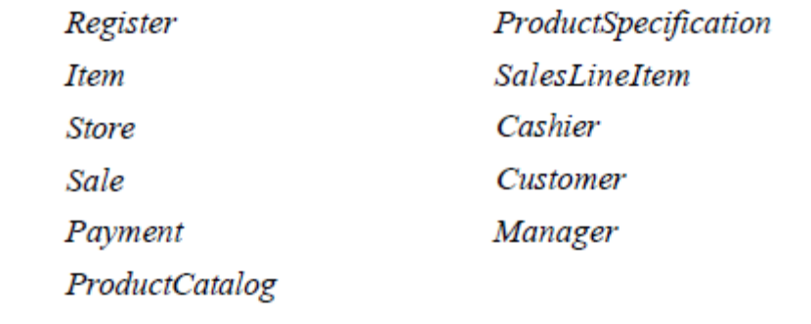

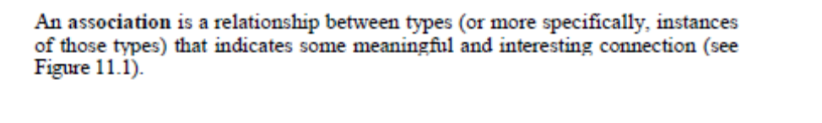

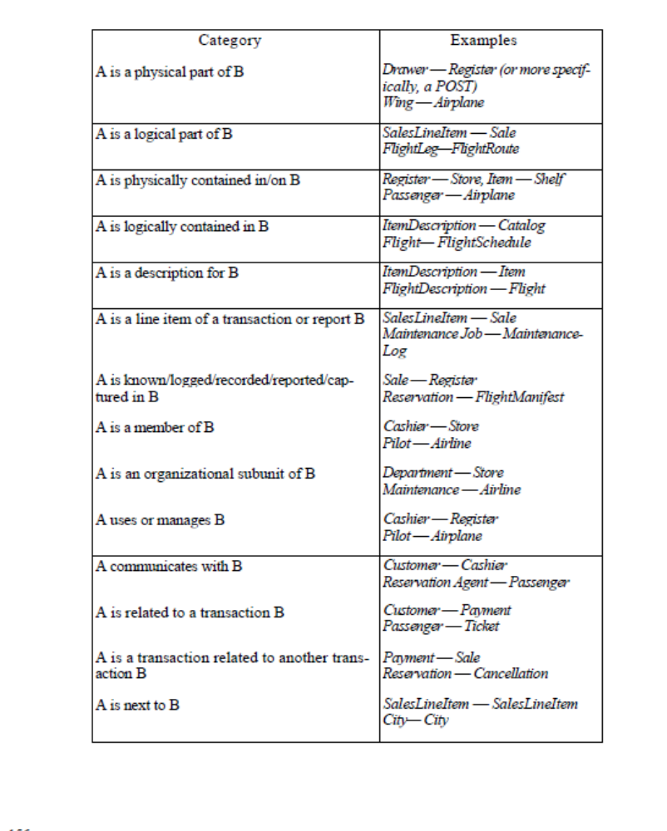

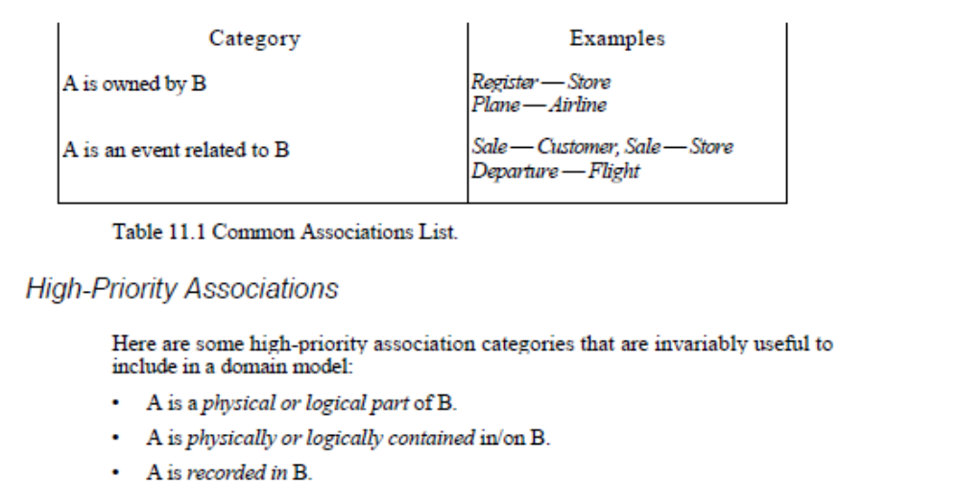

In the UML,associations are defined as the semantic relationship between two or more classifiers that involve connections among their instances
When to use an association?
Associations for which knowledge of the relationship need to be preserved for some duration.
Associations derived from the common associations list.
Why should we avoid adding many associations?
Too many associations will obscure the domain model
Will associations be implemented in software ?
IT will be implemented in software as paths of navigation and visibility.
Appyling UML?
It is line between classes with a capitalized association name.
The end of an association may contain a multiplicity expression indicating the numerical between instances of the classes.
Association is bidirectional

HOW TO NAME?
CLASS NAME-VERB PHRASE –CLASS NAME
Has,uses -----don’t use
Sale paid by cash payment
Association name should start with capital letter.
ROLE
Each end of an association is a called a role.
It has
Multiplicity expression
Name
Navigability

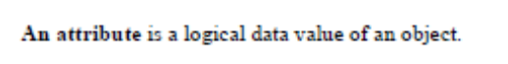

When to show attribute?
Include attribute that the requirements suggest or imply a need to remember information.
Sale –Date ,Time
Store –name ,address
Cashier-ID

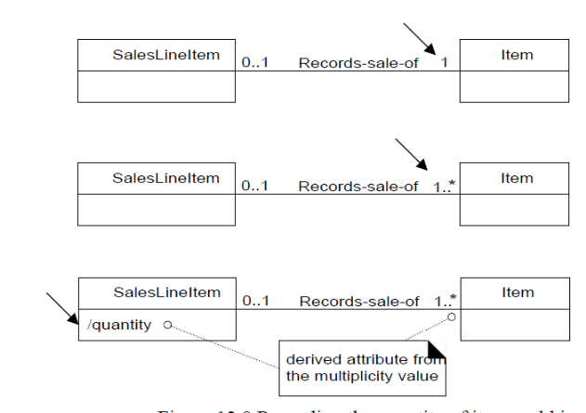

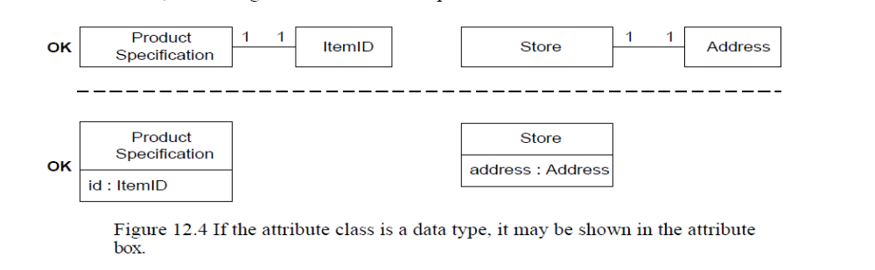
VISIBILITY variable name : type multiplicity =default {property -string }
+pi:Real=3.14{readonly}
Middlename:[0..1]
-private
+public

Data type in domain model
The type of an attribute should not be a complex domain object.
Relate conceptual classes with association, not with an attribute
There should be no attribute representing foreign key

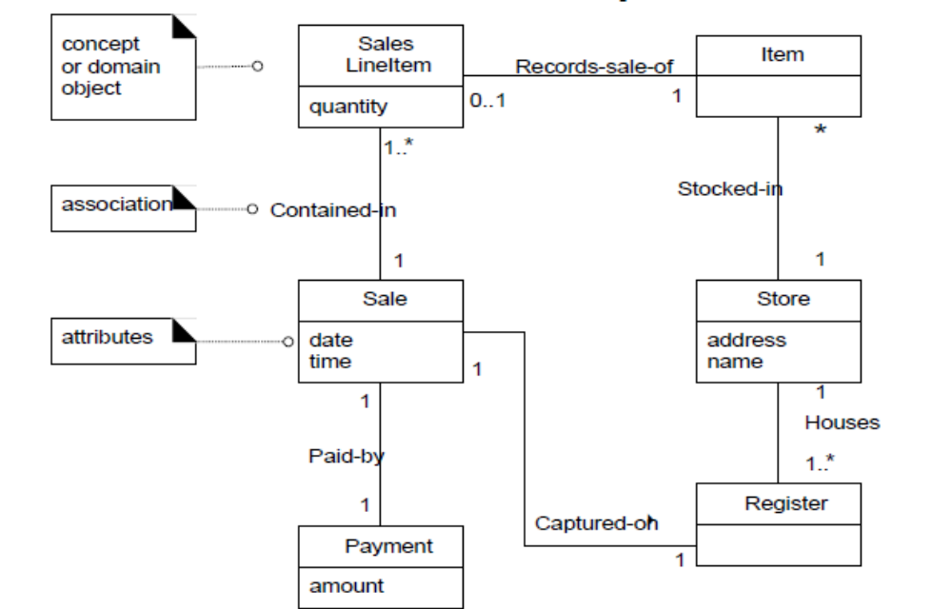

General thing to know

- Domain model is not a software object
- Visual Dictionary
- IT avoids representational gap.

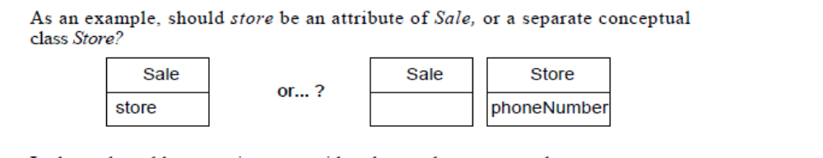

When to model description class?
A description class contains information that describes something else

